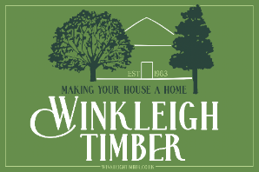

ORDERING YOUR INTERNAL DOOR(S)

WHAT WE REQUIRE FROM YOU PLEASE.

- SIZE – PLEASE PROVIDE THE ACTUAL DOOR HEIGHT AND WIDTH REQUIREMENT – PREFERABLY IN METRIC PLEASE FOR ACCURACY. DOOR THICKNESS IS APPROXIMATELY 20-22MM BOARD PLUS 20-25MM LEDGES RESULTING IN OVERAL THICKNESS 40-47MM.

- WOOD TYPE – YOU CAN SELECT FROM:
NEW, WHITE OAK
BROWN OAK – VARYING TONESOF BROWN AND WHITE
RECLAIMED KENTUCKY OAK – RUSTIC FINISH ONE SIDE, PLANED ON THE REAR
RECLAIMED PINE
RECLAIMED RUSTIC PINE – RUSTIC ONE SIDE AND PLANED ON THE REAR

- NAILS – CUT CLASP OR ROSEHEAD?

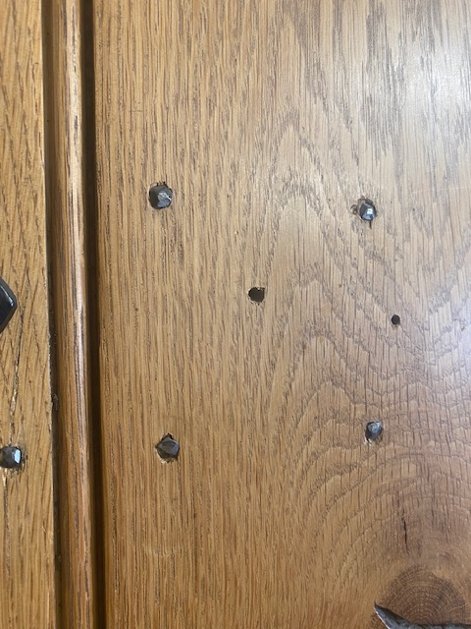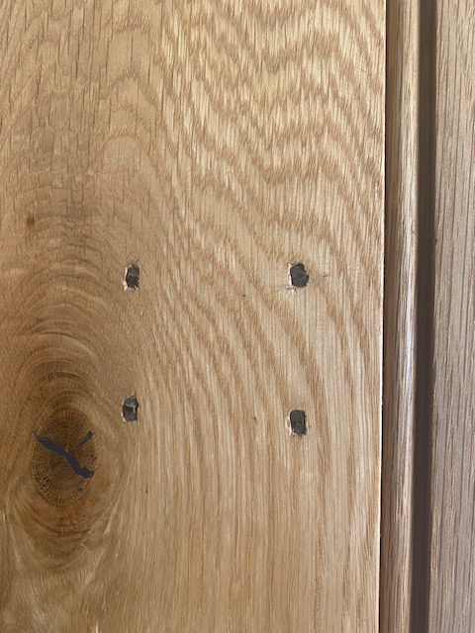

ROSEHEAD CUT CLASP

- PREFER NO NAILS? WE CAN SCREW AND PLUG THE DOORS SO THAT THERE ARE NO VISABALE NAILS IF YOU PREFER?

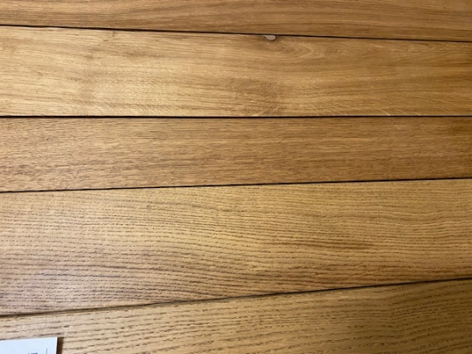
SCREWED AND PLUGGED – NO NAILS

- DETAIL – WOULD YOU LIKE A 10MM BEAD DETAIL OR JUST EASED EDGES
BETWEEN THE BOARDS?

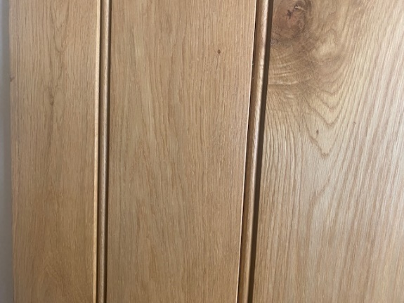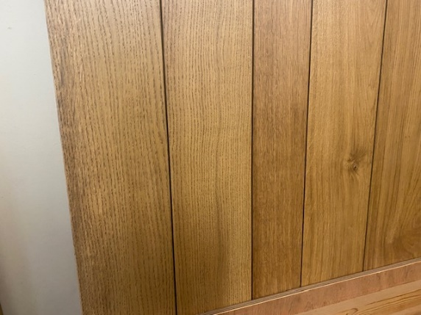

10MM BEAD BETWEEN BOARDS EASED EDGES BETWEEN BOARDS

6) FINISH – WOULD YOU LIKE OUR TRADITIONAL HAND WAX POLISH FINISH OR WOULD YOU LIKE THE DOORS SUPPLIED SANDED AND WITHOUT FINISH? TIMBER DOES REQUIRE SEALING TO AVOID TAKING ON MOISTURE THEREFORE, WE RECOMMEND SEALING THE DOOR(S) WITH A WAX OR OIL AS SOON AFTER MANUFACTURE AS POSSIBLE.

- LEDGE ONLY OR LEDGE AND BRACE? WE CAN OFFER BOTH STYLES. LEDGE ONLY IS PERFECTLY SATISFACTORY IF YOU LIKE THE LOOK OR MAYBE YOU ARE MATCHING SOME EXISITING DOORS IN THE HOUSE. ADDING THE DIAGONAL BRACE DOES GIVE THE DOOR EXTRA SUPPORT AND WE WOULD ALWAYS RECOMMEND THIS AS OUR FIRST CHOICE.

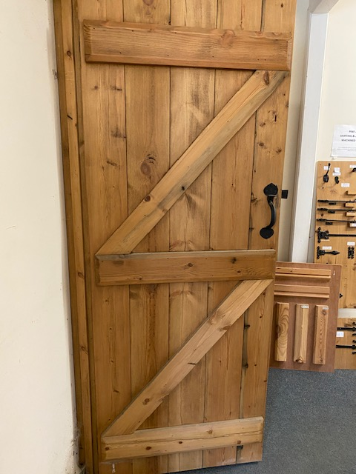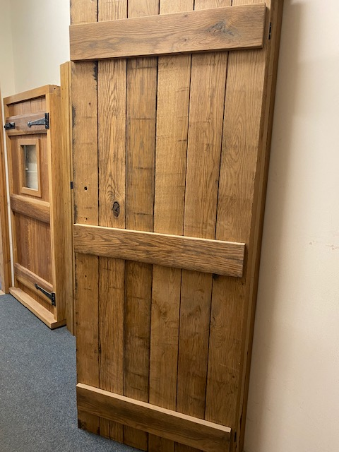
LEDGE AND BRACE DOOR LEDGE ONLY DOOR

- OPENING – WE REQUIRE THE OPENING DETAIL FOR EACH INDIVIAL DOOR. IF YOU SELECT LEDGE ONLY, WE CAN STEP THE LEDGES IN 10MM EITHER SIDE WHICH WILL ALLOW YOU TO HANG THE DOOR WHICHEVER WAY YOU DESIRE. ALTERNATIVELY, IF YOU ADVISE THE HANGING DETAIL, OUR JOINERS CAN MAKE EACH DOOR TO HANG ACCORDINGLY. LIKEWISE, FOR LEDGE AND BRACE STYLE, WE DEFINIETLY NEED THE HANGING DETAILS AS THIS WILL DETERMINE WHICH WAY THE DIAGONAL BRACE IS POSITIONED.

- HANGING/OPENING DETAIL. IT IS VERY COMMON TO GET CONFUSED BY THIS BUT, IT IS RELATIVELY SIMPLE ONCE YOU THINK IT THROUGH, ONE DOOR AT A TIME. THE BOARDED FACE OF THE DOOR, WITH THE VERTICAL PLANKS IS THE ‘GOOD FACE’ OF THE DOOR. THIS LEAVES THE REAR OF THE DOOR, WITH THE LEDGE AND BRACE OR LEDGE ONLY. WHEN LOOKING AT THE GOOD FACE OF THE DOOR – PLEASE INDICATE WHICH SIDE THE DOOR WILL BE HINGED FROM – LEFT OR RIGHT?

10) WHILST LOOKING AT THE GOOD FACE AND HAVING DETERMNED WHICH SIDE IT WILL BE HINGED, PLEASE THEN DECIDE:

IF IT WILL OPEN INWARDS TO THE ROOM AHEAD ‘OPENING IN’
OR
OUTWARDS, TOWARDS YOUR PERSON ‘OPENING OUT’.

PLEASE SEE DIAGRAMS BELOW TO ASSIST – X = YOU

----------- ------------ ---------- ------------- X X
LEFT HAND HINGE – OPEN OUT LEFT HAND HINGE – OPEN IN

----------- ----------- ----------- -----------

X X

RIGHT HAND HINGE – OPEN IN RIGHT HAND HINGE – OPEN OUT

- DOOR FURNITURE – WE DO NOT FIT THE DOOR FURNITURE, THIS SHOULD BE CARRIED OUT BY THE FITTER ON SITE WHEN HANGING YOUR DOOR(S). WE CAN OFFER OUR CAST RANGE OF LATCHES AND HINGES OR ALTERNATIVELY, OUR HAND FORGED RANGE OF PENNEY END LATCHES AND HINGES.
PLEASE NOTE, TRADITIONAL LEDGE AND BRACE DOORS ARE DESIGNED FOR TEE HINGES AS OPPOSED TO BUTT HINGES. TEE HINGES HAVE APPROXIMATELY A 30-45MM MOUNTING PLATE THEREFORE, YOU DOOR FRAME NEEDS TO BE THICK ENOUGH OR YOU MAYBE NEED TO MAKE A CUT OUT INTO YOUR ARCHITRAVE TO ACCOMMODATE.

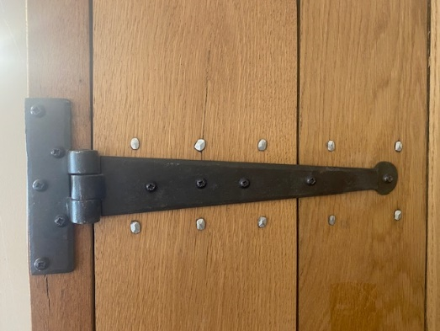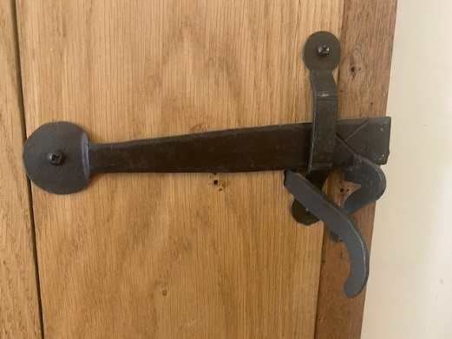
H/F PENNEY END HINGE H/F PENNEY END LATCH

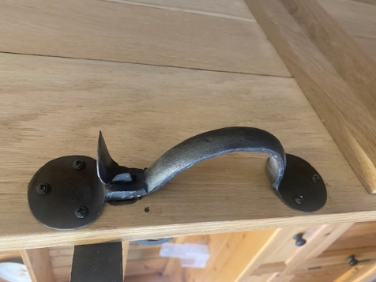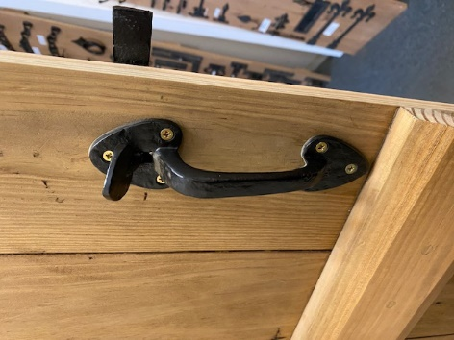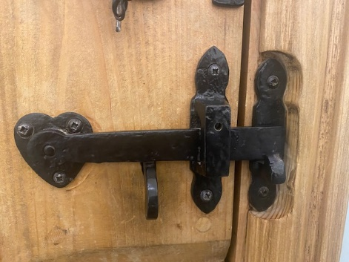
H/F PENNEY END LATCH CAST THUMB LATCH CAST THUMB LATCH

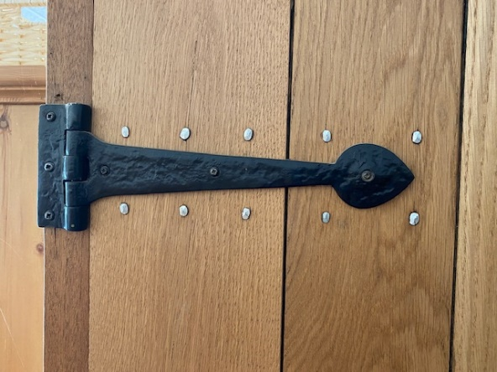
CAST TEE HINGE

PLEASE NOTE, ALL OF OUR DOORS ARE HANDMADE INDIVUALLY TO ORDER REQUIREMENT. ALL TIMBER USED IS KILN DRIED AND SUITABLE FOR INTERIOR DOORS. WE RECOMMEND HANGING YOUR DOORS AS SOON AS POSSIBLE AND KEEPING THEM IN A CLOSED/LATCHED POSITION – PARTICULARLY WHILST THEY ACCLIMATISE IN THE HOUSE. IF DOORS ARE TO BE STORED PRIOR TO HANGING THEN WE RECOMMEND THEY ARE LAID FLAT ON THE FLOOR, WITH A PROTECTIVE WEIGHT PLACED UPON THEM TO AVOID ANY TWISTING/MOVEMENT WITHIN THE TIMBERS.

SHOULD YOU HAVE ANY FURTHER QUESTIONS IN RELATION TO OUR BESPOKE, HAND MADE INTERNAL DOORS, PLEASE DO NOT HESITATE TO CONTACT US.

Seckington Cross Ind Estate, Winkleigh, Devon, EX19 8DQ
furniture@winkleightimber.co.uk
01837 83832

